Two Addresses in One Row
If we receive your address file and there is more than one address in each row, we will determine which addresses to use.
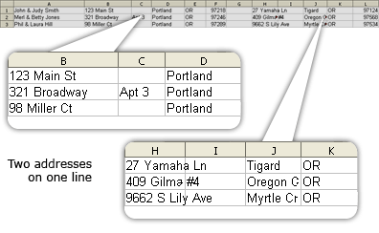

Multiple Worksheets
Excel address files must have only 1 worksheet with information on it. If files are submitted with multiple worksheets, there is a chance that your order will print with unexpected results or your order will be stopped and you will be required to re-submit your address list with only one sheet of information.
Incorrect Example

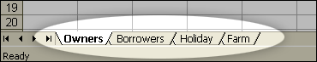

Instructions for Combining Fields

We will allow up to 5 separate columns/fields for the street address. If you have more than 5 columns/fields of street address information, you will need to combine some of those. Here are instructions for combining fields.

- Insert blank column to the right of the fields to be combined.
- In the example below type the following formula

=b2&” “&c2&” “&d2 (the &” “& places a space between fields)

- Highlight the cell with the formula and copy to the clipboard
- Highlight the column and paste the formula to the column
- Hit the escape key
- Highlight the column and copy to clipboard
- Right click on the column and hit paste special and mark the radio button labeled value
- Hit OK
- Now you should be able to delete the original columns that you have combined

In this example, we would like to combine columns B, C and D.
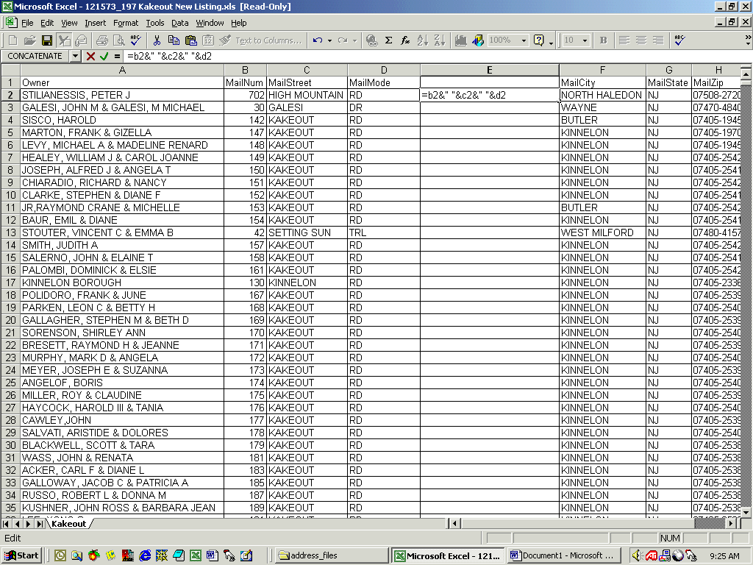

Now the columns are combined.
